# 4.2 A SPATIAL DATA

The program is intended for viewing 3d images with volume data. Volume rendering techniques are used to visualize 3D data on a 2D surface. The benefits of this includes better understanding of the knowledge in virous fields. For example, we can visualize a human brain in 3d with all the information like the neuron density and blood vessels to help us identify any tumour in a brain (MRI). Thin slices(pictures) of the object are stacked against each other to generate the 3D shape. This technique is also used in rendering 3D surface of maps like mountain ranges. This gives us more information related to surface. Programs like this helps us to visualize this 3D data by generating a projection of the 3D image on 2d surface and calculating the pixel values depending on the encoding of the data required to view.

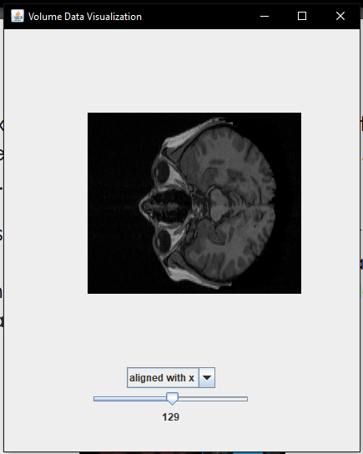

Loaded MRbrain data from [here](http://graphics.stanford.edu/data/voldata/). Viewed data along x axis by selecting the slider.There are total 109 slices for the MRI data of a human brain, each one containing a 256 x 256 bit values of the image.